
Picturing Economics Competition

Grades K-12

RULES FOR ENTRY:
- Teachers may submit up to ten (10) calendar entries - Grades K to 12.
- Teachers should submit one completed entry form per each entry.
- All entries submitted must be original entries drawn horizontally/landscape on an 8½ x 11” white sheet of paper.
- All entries should be color, not black and white.
- The entry should illustrate an economic concept provided in the glossary. If concepts are combined, each should be illustrated.
- The economic concept illustrated should be printed clearly on the drawing, spelled correctly and written in large lettering.
- All entries will be judged on accuracy of content, spelling, artistic excellence, geographic and grade level distribution.


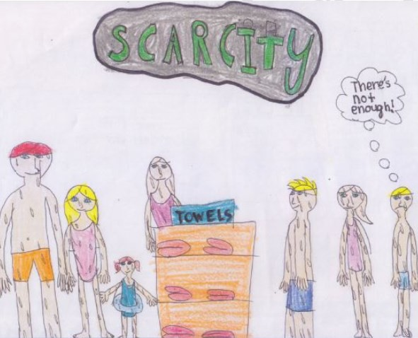
- Entries may not be folded and child’s name should not appear on the picture.
- All entries should be postmarked by Friday, December 18, 2026.
- No brand name or trademarks may be used.
- Economics resource websites: www.economicsarkansas.org.

WINNERS:
- Winning students and their teachers will receive a $50 prize.
- Winners will be chosen and announced by January 15, 2027.
- Winning entries will be spotlighted on Economics Arkansas social media sites.

TAPE this entry form to the back of each student’s calendar entry.
Please PRINT

Teacher’s Name: Please PRINT
E-mail: Student’s Name:

Phone: ( ) Grade:

School:

County: Please mail entry form and artwork to:

School District: Economics Arkansas
P.O. Box 3447
Address: Little Rock, AR 72203

City: Zip Code: For more information, visit our website:
www.economicsarkansas.org or call (501) 682-4230

Grade(s):

ENTRIES MUST BE POSTMARKED BY DECEMBER 18, 2026.


TAPE this entry form to the back of each student’s calendar entry.
Please PRINT

Teacher’s Name: Please PRINT

E-mail: Student’s Name:

Phone: ( ) Grade:

School:

County: Please mail entry form and artwork to:

School District: Economics Arkansas
P.O. Box 3447
Address: Little Rock, AR 72203

City: Zip Code: For more information, visit our website:
www.economicsarkansas.org or call (501) 682-4230

Grade(s):

ENTRIES MUST BE POSTMARKED BY DECEMBER 18, 2026.

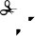

TAPE this entry form to the back of each student’s calendar entry.
Please PRINT

Teacher’s Name: Please PRINT

E-mail: Student’s Name:

Phone: ( ) Grade:

School:

County: Please mail entry form and artwork to:

School District: Economics Arkansas
P.O. Box 3447
Address: Little Rock, AR 72203

City: Zip Code: For more information, visit our website:
www.economicsarkansas.org or call (501) 682-4230

Grade(s):

ENTRIES MUST BE POSTMARKED BY DECEMBER 18, 2026.

