Affair honors ex-CEO of Wal-Mart
Share on facebookShare on twitterMore Sharing Services0
By Chris Bahn
This article was published today at 1:53 a.m.
- Comments
- aAFont Size
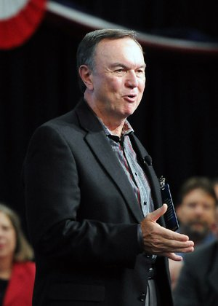
PHOTO BY NWA MEDIA
STAFF PHOTO SAMANTHA BAKER w @NWASamantha Mike Duke, Walmart Stores, Inc. chief executive officer, speaks during a Walmart Home Office meeting Monday, Nov. 11, 2013, in Bentonville. Walmart representatives and actor Gary Sinise honored veterans and discussed the importance of supporting veterans.
When Mike Duke assumed the role of Wal-Mart chief executive officer in 2009, the retailer listed operations in 15 international markets with about 3,600 stores. When Duke stepped down in February after five years at the helm, the company's global reach extended to 27 countries and more than 11,000 locations.
Duke's guidance in expanding Wal-Mart's global footprint was the focus of a Monday luncheon. Wal-Mart board member and Arvest Bank CEO Jim Walton, former Gov. Mike Huckabee and current Wal-Mart CEO Doug McMillon paid tribute to Duke, and the former CEO was presented the Excellence in Free Enterprise Award by Economics Arkansas, a nonprofit organization that promotes economic and financial literacy among students.
Huckabee, the event's keynote speaker, said Duke led the company to "some of its greatest days. It's an amazing success story."
"If we can teach one great lesson to young people today, it would be to show the people that the kind of entrepreneurship and free enterprise lessons you see in people like Mike Duke is exactly what made America a wonderful, great country," Huckabee said. "Anybody at any economic level can move up the ladder if they're willing to work hard, find an idea, improve on it and offer it for a price that people are willing to pay."
Duke, who earned $21 million last year as Wal-Mart CEO, stepped down Feb. 1 but remains with the company as an adviser to his successor until the end of McMillon's first year. Duke also is chairman of the Wal-Mart board's executive committee.
There were hiccups during Duke's tenure as CEO. Wal-Mart is expected to spend $300 million fighting allegations that it violated the Foreign Corrupt Practices Act in Mexico, China and India during its push for international expansion. Duke has denied knowledge of the incidents that led to the charges. Sales have declined or remained flat in U.S. stores as international business has grown.
Duke joined the company in 1995 when Wal-Mart had total revenue of $83 billion. Revenue for Wal-Mart's most recent fiscal year was more than $473 billion, said Bob Boehmler, Economics Arkansas board member and Arvest Benton County executive vice president.
McMillon declined to offer a comment immediately after the luncheon, but in a video tribute, he lauded Duke for his "strength of character" and "ability to be a servant leader." Prior to being named CEO, McMillon served as head of Wal-Mart International.
"Mike moved this company forward," McMillon said. "He's leaving it stronger, more global, more focused on technology in the digital age. We want to say thank you, Mike. Thank you very much."
Throughout his tenure as CEO, Duke said outsiders often questioned how the world's largest retailer could be the product of a state as small as Arkansas. Wal-Mart was founded by Sam Walton in 1962, and the company has remained headquartered in Northwest Arkansas.
"So many times, a number of times, when I was traveling around the world ... someone would ask about Wal-Mart. They'd ask how the world's largest corporation is based in Arkansas. I'd say, 'Come visit and you'll understand,'" Duke said during his acceptance speech. "It's not a surprise at all. When you're here and you feel the environment, the culture, the feel of entrepreneurship in this great state, it's not surprising. What is happening here with Economics Arkansas has helped create that environment. We can continue to build that environment for this great state."
Business on 10/28/2014
Print Headline: Affair honors ex-CEO of Wal-Mart

