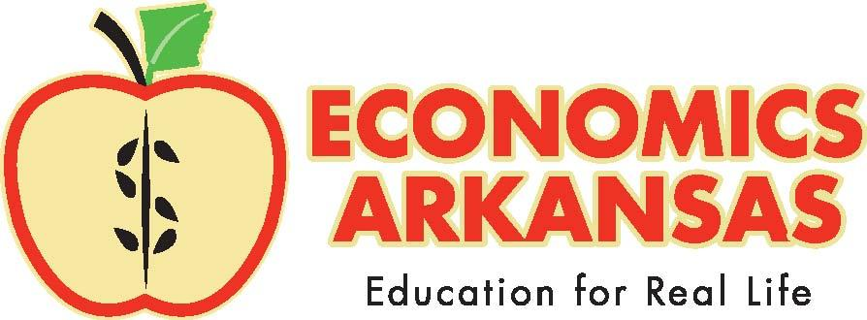

For more information, contact

Claudia Utley, Communications Director

501-682-4230

[Claudia@economicsarkansas.org](mailto:Claudia@economicsarkansas.org)

P.O. Box 3447

Little Rock, AR 72203

January 23, 2020

media Advisory

**Who:** 517 LRSD Students and First Financial Bank, Little Rock

**What:** Check presentation:   
Bank is donating $2,800+ to pay for students’ participation in Stock Market Game

**When:** Friday, Jan. 31, 10 am.

**Where:** Dunbar Magnet Middle School, 1100 Wright Ave., Little Rock

First Financial Bank of Little Rock is paying the team fees of 517 LRSD students, a total of $2,835, to participate in the 2019-20 Stock Market GameTM. This nationwide investment simulation competition for students in grades 4-12 teaches money and investing skills by challenging the participants to invest a hypothetical $100,000 portfolio live in the US securities market.

Students learn money and investment skills that benefit them for life. In addition, they improve their research and analytical skills and deepen their understanding of math, reading, economics and global events.

Chris Johnson of First Financial Bank will present the check to Economics Arkansas, which is facilitating the initiative in Arkansas. Dunbar Magnet Middle School students will be available to answer media questions about their Stock Market Game experience. Superintendent Mike Poore and Dunbar’s principal, Eunice Thrasher, will also be in attendance.

The following LRDS student teams are benefitting from FFB’s support:



Check presentations at all schools are scheduled throughout the day on Jan. 31.