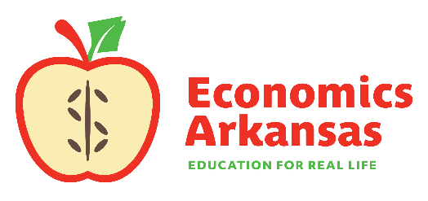
For more information, contact:
Kathleen Lawson, Executive Director
501-682-4230
kathleen@economicsarkansas.org

February 15, 2023

For Immediate Release
For Release to Statewide Media

Economics arkansas presents leadership award to shelley simpson
GOVERNOR SANDERS TO DELIVER KEYNOTE ADDRESS

LITTLE ROCK– Economics Arkansas will present the Excellence in Free Enterprise Award to Shelley Simpson, President J.B. Hunt. The awards luncheon will take place on March 15 at the Embassy Suites Convention Center in Rogers.
J.B. Hunt CEO John Roberts will present the award to Simpson. Newly inaugurated Arkansas Governor Sarah Huckabee Sanders will deliver the keynote address.
“We are pleased to present this award to Shelley,” said Kathleen Lawson, Economics Arkansas executive director. “Shelley’s long tenure with J.B. Hunt starting from an hourly customer service representative to now President of the company demonstrates one’s own ability to leverage the free enterprise system to transform their own success.”
The Excellence in Free Enterprise award honors those who promote success in the free market. Economics Arkansas will recognize Simpson for her innovative leadership and commitment to company-wide advancement.
Simpson has been with J.B. Hunt for 28 years, most recently serving as Chief Commercial Officer and EVP of People and Human Resources. The board of directors elected her as President in July 2022.
Since 2012, the Excellence in Free Enterprise Award has been presented to exceptional individuals whose entrepreneurial spirit and business acumen have improved the lives of countless people across the region, the nation and the world. Previous recipients include Sam Walton (posthumously), J.B. and Johnelle Hunt, Don Tyson (posthumously), Mike Duke, Governor Asa Hutchinson, and the families of George’s Inc. and Simmons Foods Inc.

Economics Arkansas is a private, nonprofit, non-partisan educational organization founded in 1962 by Dr. Arch Ford and led by Dr. Bessie B. Moore to promote economic literacy in Arkansas. Its mission is to equip PreK-12 schools with standards-based resources and professional development to teach economics, personal finance, and the free-enterprise system using practical, innovative, and inspiring methods so that Arkansas students may master an understanding of economics and personal finance and apply that knowledge for success in the free-enterprise system.

Economics Arkansas | P.O. Box 3447, Little Rock, AR 72203 | 501-682-4230 | www.economicsarkansas.org

–###–

