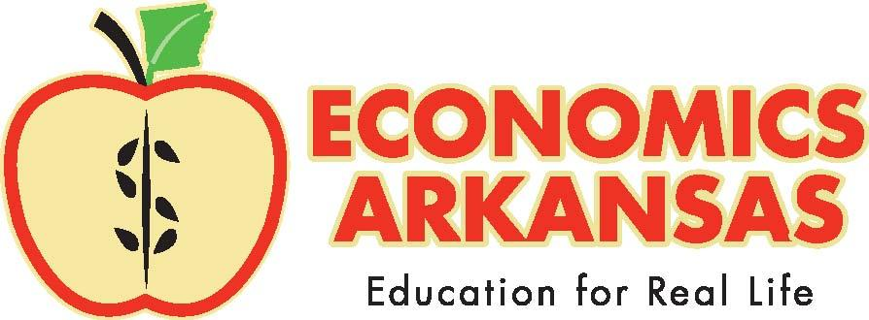
For more information, contact:
Kathleen Lawson, Executive Director
501-682-4230
kathleen@economicsarkansas.org

August 19, 2021

For Immediate Release
For Release to Statewide Media

ECONOMICS ARKANSAS RECEIVES $12,000 GRANT FROM THE DELTA DENTAL OF ARKANSAS FOUNDATION

LITTLE ROCK– Economics Arkansas recently received $12,000 from the Delta Dental of Arkansas Foundation to launch an economic and oral health literacy initiative in fall 2021 targeting Arkansas elementary students and teachers.

Having healthy habits at an early age will prevent one of the top barriers to oral health care as adults: oral health literacy. Improving oral health literacy in young children will break down the fear Arkansas students have of receiving dental services. In the same fashion, forming healthy financial habits at an early age – such as good decision-making skills and knowing the importance of budgeting and saving – can mean the difference between prosperity and poverty later on.

Next month, grade-appropriate classroom lesson plans on decision-making will accompany copies of Just Going to the Dentist by Mercer Mayer mailed to almost 600 elementary media specialists in the state. Educators can use these resources to show students how everyday decisions can have long-term effects, like brushing and flossing your teeth.

To promote the initiative and in recognition of World Smile Day on October 1, six regional mini-events will be held at the following schools: Jones Elementary (Springdale), Bobby Barrett Elementary (Mount Ida), East Side Elementary (Magnolia), Hill Farm Elementary (Bryant), Clarendon Elementary, and Hermitage Elementary.

Students attending these mini-events will receive a personal copy of Just Going to the Dentist and a family activity guide, as well as a “Grin for Kids” coloring book and toothbrush donated by Delta Dental of Arkansas.

Through the Community Education Grant program, the Delta Dental of Arkansas Foundation seeks to expand access to oral health care in underserved areas. Grant recipients were selected based on the innovativeness of the proposed project and its potential impact on the oral health of Arkansans.

“We are proud to recognize the work being done by Economics Arkansas by selecting it as one of our grant recipients,” said Chrissy Chatham, executive director of the Delta Dental of Arkansas Foundation. “By increasing access to dental care, we can help improve the oral and overall health and well-being of children and adults by preventing serious health issues down the road.”

Delta Dental of Arkansas Foundation is committed to fulfilling Delta Dental’s mission to improve the oral health of Arkansans. Since 2015, the Foundation has contributed an average of $3 million annually to support oral health programs and initiatives. By investing in education, prevention and treatment, we are working to make Arkansas healthier, one smile at a time.
For more oral health news and information, visit www.DeltaDentalAR.com and follow us on Twitter, Facebook, LinkedIn and Instagram at @DeltaDentalAR.

Economics Arkansas is a private, non-profit, non-partisan educational organization founded in 1962 by Dr. Arch Ford and led by Dr. Bessie B. Moore to promote economic literacy in Arkansas. Its mission is to equip PreK-12 schools with standards-based resources and professional development to teach economics, personal finance, and the free-enterprise system using practical, innovative, and inspiring methods so that Arkansas students may master an understanding of economics and personal finance and apply that knowledge for success in the free-enterprise system.

Economics Arkansas | P.O. Box 3447, Little Rock, AR 72203 | 501-682-4230 | www.economicsarkansas.org

–###–

