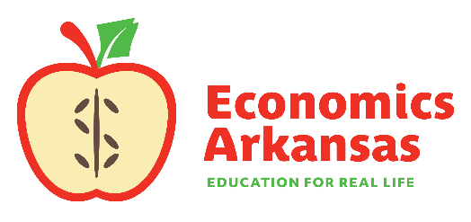
For more information, contact:
Kathleen Lawson, Executive Director
501-682-4230
kathleen@economicsarkansas.org

July 18, 2022

For Release to Statewide Media
For Immediate Release

11th Annual Economics and Personal Finance Conference Offers Professional Development Opportunities for Educators

LITTLE ROCK—This week, more than 170 teachers from across the state will gather in Little Rock to learn from premier experts in academia and business on a wide variety of economic, personal finance and entrepreneurship topics. Titled REAL Econ for All, this is the 11th year this conference is being offered by Economics Arkansas. The conference will open with a welcome from Matuschka Lindo Briggs, who was recently named Vice President and Regional Executive of the Little Rock Branch of the Federal Reserve Bank of St. Louis.
Conference attendees will get to choose from more than 60 breakout sessions taught by Master of Economics teachers, university professors, and representatives from government agencies and private industry. Upon successful completion, conference participants will receive up to 12 hours of Arkansas Department of Education-certified professional development, grade-level appropriate lesson plans and classroom materials, and a stipend.
“In a time when economic issues are making headlines, it’s all the more evident that economic education matters,” said Kathleen Lawson, executive director at Economics Arkansas. “Students need to understand economic principles so that they can be informed and engaged citizens, knowledgeable consumers and wise investors. Equipping teachers with the tools and confidence to bring real life economics into the classroom is a critical step to student success.”
The conference will be held at Don Roberts Elementary, 16601 Lamarche Drive, Little Rock on Wednesday, July 20th and Thursday, July 21st from 8:30-4:30 daily.

Economics Arkansas is a private, non-profit, non-partisan, educational organization founded in 1962 by Dr. Arch Ford and led by Dr. Bessie B. Moore to promote economic literacy in Arkansas. Its mission is to equip PreK-12 schools with training and resources to teach economics and personal finance using practical, innovative and inspiring methods so that Arkansas students may become economically and financially literate, allowing them to achieve their own American dream and thrive in a free-market economy.

###

